WEATHER FORECASTING

## A PROJECT REPORT

*Submitted by*

## RENUSRI P-(2303811724322088)

## REXCIA A-(2303811724322089)

## RUKSHITA G-(2303811724322092) SAHANA P-(2303811724322093)

*in partial fulfillment of requirements for the award of the course*

AGB1211 – DESIGN THINKING

*in*

ARTIFICIAL INTELLIGENCE AND DATA SCIENCE

K. RAMAKRISHNAN COLLEGE OF TECHNOLOGY

(An Autonomous Institution, affiliated to Anna University Chennai and Approved by AICTE, New Delhi)

SAMAYAPURAM – 621 112

DECEMBER, 2024

K. RAMAKRISHNAN COLLEGE OF TECHNOLOGY (AUTONOMOUS)

SAMAYAPURAM – 621 112

# BONAFIDE CERTIFICATE

Certified that this project report on “WEATHER FORECASTING” is the bonafide work of **RENUSRI P-(23038117243222088) ,REXCIA A-(2303811724322089), RUKSHITA G-(2303811724321033) ,SAHANA P -(2303811724321035)** who carried out the project work during the academic year 2024 - 2025 under my supervision.

**Signature**

Dr. T. AVUDAIAPPAN M.E.,Ph.D.,

**HEAD OF THE DEPARTMENT,**

Department of Artificial Intelligence,

K. Ramakrishnan College of Technology, Samayapuram, Trichy -621 112.

**Signature**

Mrs. JOANY FRANKLIN M.E.,

**SUPERVISOR,**

Department of Artificial Intelligence,

K. Ramakrishnan College of Technology, Samayapuram, Trichy -621 112.

Submitted for the viva-voce examination held on 06.12.24

INTERNAL EXAMINER EXTERNAL EXAMINER

.

# DECLARATION

I declare that the project report on “**WEATHER FORECASTING** ” is the result of original work done by us and best of our knowledge, similar work has not been submitted to “**ANNA UNIVERSITY CHENNAI**” for the requirement of Degree of **BACHELOR OF TECHNOLOGY**. This project report is submitted on the partial fulfillment of the requirement of the award of the **AGB1211 – DESIGN THINKING.**

**Signature**

RENUSRI P

-----------------------------

REXCIA A

-------------------------------- RUKSHITA G

--------------------------------

SAHANA P

--------------------------------

Place: Samayapuram Date: 6/12/2024

## ACKNOWLEDGEMENT

It is with great pride that I express our gratitude and indebtedness to our institution, “**K. Ramakrishnan College of Technology (Autonomous)**”, for providing us with the opportunity to do this project.

I extend our sincere acknowledgement and appreciation to the esteemed and honourable Chairman, **Dr. K. RAMAKRISHNAN, B.E.,** for having provided the facilities during the course of our study in college.

I would like to express our sincere thanks to our beloved Executive Director, **Dr. S. KUPPUSAMY, MBA, Ph.D.,** for forwarding our project and offering an adequate duration to complete it.

I would like to thank **Dr. N. VASUDEVAN, M.TECH., Ph.D.,** Principal, who gave the opportunity to frame the project to full satisfaction.

I thank **Dr.T.AVUDAIAPPAN, M.E.,Ph.D.,** Head of the Department of

**ARTIFICIAL INTELLIGENCE AND DATA SCIENCE**, for providing her

encouragement in pursuing this project.

I wish to convey our profound and heartfelt gratitude to our esteemed project guide **Mrs.S.GEETHA M.E.,** Department of **ARTIFICIAL INTELLIGENCE AND DATA SCIENCE,** for her incalculable suggestions, creativity, assistance and patience, which motivated us to carry out this project.

I render our sincere thanks to the Course Coordinator and other staff members for providing valuable information during the course.

I wish to express our special thanks to the officials and Lab Technicians of our departments who rendered their help during the period of the work progress.

## VISION OF THE INSTITUTION

To serve the society by offering top-notch technical education on par with global standards.

## MISSION OF THE INSTITUTION



Be a centre of excellence for technical education in emerging technologies by exceeding the needs of industry and society.

Be an institute with world class research facilities.

Be an institute nurturing talent and enhancing competency of students to transform them as all- round personalities respecting moral and ethical values.

## VISION AND MISSION OF THE DEPARTMENT

To excel in education, innovation and research in Artificial Intelligence and Data Science to fulfil industrial demands and societal expectations.

**Mission 1:** To educate future engineers with solid fundamentals, continually improving teaching methods using modern tools.

**Mission 2:** To collaborate with industry and offer top-notch facilities in a conductive learning environment.

**Mission 3:** To foster skilled engineers and ethical innovation in AI and Data Science for global recognition and impactful research.

**Mission 4:** To tackle the societal challenge of producing capable professionals by instilling employability skills and human values.

## PROGRAM EDUCATIONAL OBJECTIVES (PEOS)

**PEO 1**: Compete on a global scale for a professional career in Artificial Intelligence and Data Science.

**PEO 2**: Provide industry-specific solutions for the society with effective communication and ethics.

**PEO 3:** Hone their professional skills through research and lifelong learning initiatives.

## PROGRAM OUTCOMES



Engineering students will be able to:

1. **Engineering knowledge:** Apply the knowledge of mathematics, science, engineering fundamentals, and an engineering specialization to the solution of complex engineering problems.
2. **Problem analysis**: Identify, formulate, review research literature, and analyze complex engineering problems reaching substantiated conclusions using first principles of mathematics, natural sciences, and engineering sciences.
3. **Design/development of solutions:** Design solutions for complex engineering problems and design system components or processes that meet the specified needs with appropriate consideration for the public health and safety, and the cultural, societal, and environmental considerations.
4. **Conduct investigations of complex problems:** Use research-based knowledge and research methods including design of experiments, analysis and interpretation of data, and synthesis of the information to provide valid conclusions.
5. **Modern tool usage**: Create, select, and apply appropriate techniques, resources, and modern engineering and IT tools including prediction and modeling to complex engineering activities with an understanding of the limitations.
6. **The engineer and society:** Apply reasoning informed by the contextual knowledge to assess societal, health, safety, legal and cultural issues and the consequent responsibilities relevant to the professional engineering practice.
7. **Environment and sustainability:** Understand the impact of the professional engineering solutions in societal and environmental contexts, and demonstrate the knowledge of, and need for sustainable development.
8. **Ethics:** Apply ethical principles and commit to professional ethics and responsibilities and norms of the engineering practice.
9. **Individual and team work:** Function effectively as an individual, and as a member or leader in diverse teams, and in multidisciplinary settings.
10. **Communication:** Communicate effectively on complex engineering activities with the engineering community and with society at large, such as, being able to comprehend and write effective reports and design documentation, make effective presentations, and give and receive clear instructions.
11. **Project management and finance:** Demonstrate knowledge and understanding of the engineering and management principles and apply these to one’s own work, as a member and leader in a team, to manage projects and in multidisciplinary environments.
12. **Life-long learning:** Recognize the need for, and have the preparation and ability to of engage technological change. in independent and life-long learning in the broadest context.

## PROGRAM SPECIFIC OUTCOMES (PSOs)



* + **PSO 1:** Capable of working on data-related methodologies and providing industry-

focussed solutions.

* + **PSO2:** Capable of analysing and providing a solution to a given real-world problem by designing an effective program.

# ABSTRACT

Weather forecasting has long faced challenges of accuracy and accessibility due to fragmented data sources and the complexity of real-time processing. This project addresses these issues by leveraging machine learning to enhance predictive capabilities and integrating diverse data streams into a unified platform. The system combines real-time data from satellites, weather stations, and sensors with advanced algorithms trained on historical and live inputs.Deliverables include a mobile-friendly application featuring intuitive interfaces, dynamic visualizations, and cross-platform compatibility. Tailored functionalities, such as real-time alerts, hourly updates, and offline access, aim to meet the needs of diverse users, including meteorologists, farmers, and outdoor professionals. This innovative approach ensures reliable, user-centric weather forecasts, contributing to improved decision-making and preparedness.

# TABLE OF CONTENTS

## CHAPTER

**No.**

## 1

**ABSTRACT INTRODUCTION**

## TITLE

**PAGE**

**No. viii 1**

* 1. INTRODUCTION 1
  2. PROBLEM STATEMENT **1**
  3. OBJECTIVE 2

1. PROJECT METHODOLOGY 3
   1. BLOCK DIAGRAM 3
2. KEY PHASES OF DESIGN THINKING 4
   1. EMPATHIZE 4
   2. DEFINE 4
   3. IDEATE 4
   4. PROTOTYPE 5
   5. TEST 5
3. MODULE DESCRIPTION 6
   1. DATA COLLECTION & PREPROCESSING 6
   2. PREDICTIVE MODEL DEVELOPMENT 6
   3. USER COMMUNICATION & ALERTS 7
4. CONCLUSION 8

REFERENCES 9

APPENDIX A – SCREENSHOTS 10

# CHAPTER 1 INTRODUCTION

## INTRODUCTION

Weather forecasting is a crucial aspect of planning and preparedness for various industries, including agriculture, transportation, event management, and disaster response. Despite advancements in technology, traditional forecasting methods often struggle with real-time data integration and user-specific solutions. This project introduces an innovative approach by employing machine learning to enhance weather prediction accuracy and deliver tailored forecasts to meet diverse user needs. With a focus on creating accessible, mobile-friendly platforms, the project addresses the growing demand for reliable, real-time forecasting tools.

## PROBLEM STATEMENT

Current weather forecasting systems face several challenges: Limited accuracy due to fragmented data from multiple sources.

Difficulties in processing and analyzing real-time inputs, such as satellite and sensor data.

Lack of user-friendly platforms that cater to specific needs, such as real-time alerts or offline access.

These limitations hinder effective decision-making for individuals and organizations reliant on accurate weather forecasts.

## OBJECTIVE

The primary objectives of this project are:

* + 1. To develop a machine learning-based system that improves weather prediction accuracy by integrating diverse data sources.
    2. To create an intuitive, cross-platform application that provides real-time weather updates, tailored forecasts, and offline access.
    3. To enable features such as dynamic visualizations, severe weather alerts, and modular updates, enhancing user engagement and decision-making capabilities.

# CHAPTER 2

# PROJECT METHODOLOGY

## 2.1 BLOCK DIAGRAM

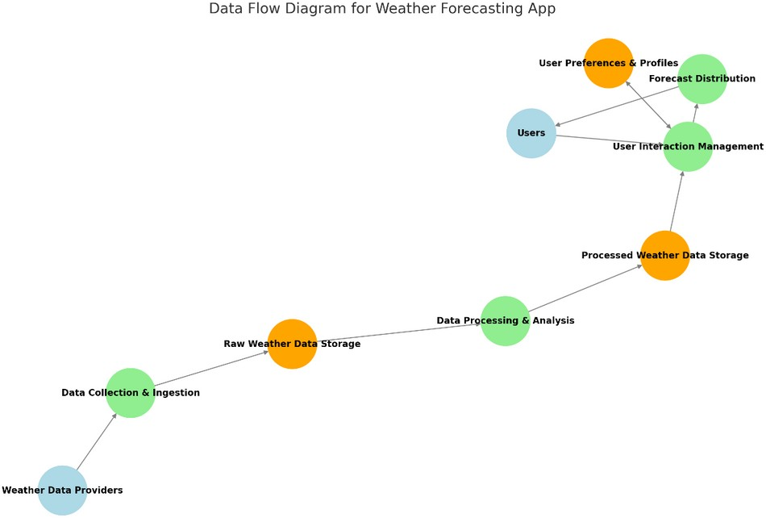

# CHAPTER 3

**KEY PHASES OF DESIGN THINKING**

## EMPATHIZE

Understanding the needs and challenges of weather forecasting users was the first step in this project. Through primary research, including user interviews and surveys, the team identified key pain points:

Meteorologists demand reliable and real-time forecasting models to improve predictions.

Farmers, event planners, and outdoor professionals require tailored forecasts for decision-making.

Users prefer mobile-friendly solutions with features like hourly updates, real- time alerts, and offline access.

Secondary research further provided insights into technological advancements in APIs, real-time data integration, and predictive modeling.

## DEFINE

The problem statement was refined to focus on:

Enhancing weather forecasting accuracy by integrating fragmented data sources.

Developing a unified, user-friendly platform for diverse needs.

Providing a reliable, real-time solution that improves user experience and decision-making.

These goals framed the project to address the current gaps in weather prediction systems effectively.

## IDEATE

Brainstorming sessions generated innovative ideas to solve the defined problems: Utilizing machine learning algorithms trained on both historical and real-time data for enhanced predictive capabilities.

Developing cross-platform applications with dynamic, interactive weather visualizations.

Incorporating modular updates to adapt to evolving user demands and weather patterns.

Designing offline-access capabilities and multi-source real-time integration for consistent data availability.

## PROTOTYPE

The prototype focused on three primary modules:

Data Collection and Processing: Aggregating real-time data from satellites, weather stations, and IoT devices with automated validation to ensure accuracy.

Predictive Model Development: Implementing machine learning models to forecast temperature, precipitation, and storms, with a modular structure for updates.

User Communication and Alerts: Building a mobile-friendly application that provides dynamic graphs, severe weather alerts, and offline forecasts.

The prototype design was created using Figma, a powerful tool for building interactive and visually appealing interfaces. Figma's capabilities were instrumental in crafting dynamic dashboards and intuitive layouts that enhance user engagement and experience.

## TEST

The prototype was tested with a diverse group of users, including meteorologists, farmers, and outdoor professionals. Feedback was gathered to:

Evaluate the accuracy of predictions compared to traditional methods. Assess the usability of the application and its features, such as real-time updates and offline access.

Identify potential areas for improvement in user interface and system performance.

Iterative testing allowed the team to refine the solution, ensuring it met the identified needs and delivered value to the target audience.

# CHAPTER 4

# MODULE DESCRIPTION

## DATA COLLECTION & PREPROCESSING



Purpose:



Gather data from multiple sources such as satellites, weather stations, and sensors.



Ensure the raw data is accurate and complete for further analysis.

Implementation:



Use APIs and IoT networks for real-time data fetching. Clean and preprocess raw data to eliminate noise or errors.



Innovations:

Automated data validation to reduce errors in input.

Real-time integration of multi-source data streams for consistency.

## PREDICTIVE MODEL DEVELOPMENT



Purpose:

Create accurate predictions for weather elements like temperature, precipitation, and storms.



Implementation:

Use machine learning models for prediction. Train models on historical and real-time data.

Innovations:

Enhanced algorithm design to adapt to evolving weather trends. Modular structure allowing easy updates and integration of new parameters.



## USER COMMUNICATION & ALERTS



Purpose:



Provide real-time alerts and easy-to-understand weather information to users.

Implementation:

Develop cross-platform apps for weather updates. Push notifications for severe weather events.



Innovations:

Interactive visualizations for weather trends (e.g., dynamic graphs). Offline access to forecasts in low-connectivity areas.



# CHAPTER 5

# CONCLUSION

This project successfully addresses the challenges in weather forecasting by leveraging the power of machine learning and real-time data integration.Through the development of a user-friendly, cross-platform application, the project enhances prediction accuracy and accessibility for diverse user groups, including meteorologists, farmers, and outdoor professionals.The modular design of the predictive models, coupled with features like dynamic visualizations, real-time alerts, and offline access, ensures adaptability and reliability. By combining advanced technologies with user- centric design, the project not only bridges existing gaps in weather prediction but also sets a foundation for future innovations in forecasting systems.This solution exemplifies how technology can be harnessed to improve decision-making, mitigate risks, and support industries dependent on accurate weather information.



## REFERENCES:

AccuWeather. (n.d.). Weather forecasting tools and technologies. Retrieved from [https://www.accuweather.com](https://www.accuweather.com/)

AWS Weather APIs. (n.d.). Real-time weather data integration. Retrieved from <https://aws.amazon.com/weather>

Climate Data Online. (n.d.). Historical weather data resources. National Centers for Environmental Information. Retrieved from https://[www.ncei.noaa.gov](http://www.ncei.noaa.gov/)

GeeksforGeeks. (n.d.). Introduction to Machine Learning for Weather Forecasting. Retrieved from [https://www.geeksforgeeks.org](https://www.geeksforgeeks.org/)

Google Developers. (n.d.). Building APIs for real-time data. Retrieved from [https://developers.google.com](https://developers.google.com/)

# APPENDIX A – SCREENSHOTS

